Data Analytics Capstone

Finance, Credit Risk Modeling

Interim Report

Laxmikant Deshpande

Walsh College

QM640: Data Analytics Capstone

Keya Choudhary Ganguly

3rd Term

20 October 2026

Contents
Introduction 4
Background and Context 4
Why the Problem Matters 4
Stakeholders 4
Operational Relevance 4
Problem Statement 5
Purpose of Study 5
Interim Project Status 6
Scope, Boundaries and Objectives 6
Research Questions 9
Research Question 1 (RQ1) – Comparative Performance: 9
Research Question 2 (RQ2) – Feature Ranking & Interpretability: 10
Research Question 3 (RQ3) – Threshold & Non-Linear Effects: 11
Research Question 4 (RQ4) – Fairness or Bias: 12
Literature Survey 13
Table: Literature relevance matrix 13
Thematic Literature Review 15
Research Gaps Identified 15
Data Description 16
Table: Dataset overview 17
Dataset Access and Reproducibility 17
Table: Data Dictionary 19
GitHub Data Availability Statement 22
Steps to Reproduce the Analysis 22
Software Environment 22
Reproducibility Controls 23
Screenshots / Evidence (as required) 24
Data Cleaning 24
Data Cleaning Log: 25
Exploratory Data Analysis: 26
Table: EDA insight summary 32
Exploratory Data Analysis (EDA): 33
Sample Size Calculations (Power/CI): 34
Modelling 36
Table: Choice of Models with Justification 36
Features Included and Feature Engineering 37
Table: Feature set and usage 37
Table: Evaluation Metrics 39
Table: Preliminary model performance comparison 40
Preliminary Model Performance 40
Interim Limitations and Risks 41
Next Steps (for Final Report) 41
Bibliography 42
References 43
Appendix 44

Introduction

Background and Context
Credit risk modeling is a cornerstone of modern financial systems, serving as the basis for lending decisions, regulatory compliance, and risk management. Financial institutions rely on predictive models to assess the likelihood that borrowers will default on loans, thereby safeguarding profitability and ensuring the stability of the broader economy. With the increasing digitization of financial services and the rise of fintech platforms, the demand for accurate, transparent, and fair credit scoring models has intensified

Why the Problem Matters
Traditional credit scoring methods, such as logistic regression, have provided a foundation for decades. However, these approaches often fail to capture complex, nonlinear relationships in borrower behavior and may inadvertently introduce bias against certain demographic groups. Machine learning and artificial intelligence techniques offer the potential to improve predictive accuracy and fairness, but they also raise concerns about interpretability and ethical governance. Addressing these challenges is critical for ensuring equitable access to credit and maintaining trust in financial systems.

Stakeholders
The stakeholders in credit risk modeling are diverse. Banks and financial institutions seek models that minimize default rates while maximizing lending opportunities. Regulators demand transparency and fairness to prevent discriminatory practices. Borrowers, particularly those from marginalized communities, are directly impacted by the fairness of credit scoring systems, as biased models can restrict access to essential financial services. Policymakers and governance bodies are increasingly focused on ensuring that AI-driven credit scoring aligns with ethical and legal standards.

Operational Relevance
Operationally, improved credit risk models can reduce financial losses, enhance customer trust, and support broader goals of financial inclusion. By integrating statistical, machine learning, and deep learning approaches, organizations can develop robust systems that balance predictive performance with fairness and interpretability. This research contributes to both academic discourse and practical applications, offering insights into how AI can be responsibly deployed in high-stakes financial decision-making.

Problem Statement
Credit risk assessment plays a critical role in lending decisions, risk management, portfolio monitoring, and regulatory compliance within financial institutions (Noriega et al., 2023). Traditional credit scoring approaches often focus on binary borrower classification, categorizing applicants as either good or bad credit risks. While useful, such classifications provide limited support for risk-based pricing, capital allocation, portfolio management, and regulatory decision-making (Lessmann et al., 2015).
This study addresses the problem of estimating the Probability of Default (PD), defined as the likelihood that a borrower will fail to meet repayment obligations in the subsequent month. Using the Taiwan Credit Card Default dataset from the UCI Machine Learning Repository, the study investigates whether advanced machine learning techniques can improve predictive performance, interpretability, threshold detection, and fairness compared with traditional statistical methods (Aboulmaouda et al., 2026; Suhadolnik et al., 2023).
The target variable is CreditRisk (labelled “default payment next month” in the source file), where a value of 1 indicates that the customer defaulted on the payment due in the month following the last observed billing cycle (September 2005) and 0 indicates non-default (Yeh & Lien, 2009). The analysis uses 31 predictor variables in six groups: the 23 original variables in the dataset and 8 engineered features that operationalise the threshold and repayment-behaviour questions (RQ2 and RQ3):
- Demographic (4): SEX, AGE, EDUCATION, MARRIAGE.
- Credit limit (1): LIMIT_BAL (credit limit in NT$).
- Repayment status (6): PAY_0, PAY_2, PAY_3, PAY_4, PAY_5, PAY_6 (repayment status from September back to April 2005; the source file has no PAY_1).
- Billing (6): BILL_AMT1 to BILL_AMT6 (monthly bill statement amounts in NT$).
- Payment (6): PAY_AMT1 to PAY_AMT6 (monthly payment amounts in NT$).
- Engineered (8):
    - TOTAL_BILL ,
    - TOTAL_PAY,
    - AVG_UTIL_RATIO,
    - AVG_PAY_RATIO,
    - BILL_TREND,
    - PAY_TREND,
    - MISSED_PAYMENTS,
    - OVERPAYMENTS
The customer identifier (ID) is excluded from modelling. In addition to predictive performance, the study evaluates model interpretability and fairness, which have become increasingly important requirements in modern credit risk assessment frameworks (Alcarva, 2026; Vieira et al., 2025).

Purpose of Study
The purpose of this study is to design, implement, and evaluate machine learning techniques for probability of default estimation using credit card customer data. Unlike conventional classification approaches that focus solely on identifying defaulters, this research seeks to develop models capable of estimating default risk while maintaining transparency, fairness, and practical relevance to credit risk management (Aboulmaouda et al., 2026; Alcarva, 2026).
The study has four primary objectives. These objectives are informed by prior research highlighting the importance of predictive performance, interpretability, threshold detection, and fairness in modern credit risk assessment systems (Noriega et al., 2023; Vieira et al., 2025).
- Compare the predictive performance of traditional statistical models and advanced machine learning models in estimating probability of default.
- Identify and interpret the most influential predictors of default risk using explainable artificial intelligence techniques.
- Detect threshold effects and nonlinear relationships among borrower characteristics and repayment behaviour.
- Evaluate potential demographic bias and investigate fairness-aware techniques that improve equity while maintaining predictive performance.

Interim Project Status
Completed (Weeks 1–3):
- Problem definition, research questions and literature survey
- Data collection, cleaning and exploratory data analysis
- Feature engineering (8 engineered features)
- Train/test split and baseline Logistic Regression model, with preliminary evaluation
In progress:
- Designing the cross-validation and hyperparameter tuning pipeline for the remaining models
- Preparing the interpretability and fairness analysis setup (RQ2–RQ4)
Pending (Weeks 4–10):
- Training of Decision Tree, Random Forest, Gradient Boosting, XGBoost and Neural Network models
- Hyperparameter tuning and final validation on a held-out test set
- Interpretability analysis (feature importance, permutation importance, SHAP, LIME)
- Threshold and non-linear effect analysis
- Fairness evaluation and bias mitigation
- Final report and recommendations

Scope, Boundaries and Objectives
This study estimates the Probability of Default (PD) of credit card customers using the Taiwan Credit Card Default dataset from the UCI Machine Learning Repository (Yeh, 2016; Yeh & Lien, 2009). The unit of analysis is the individual card holder, and the data covers six monthly billing and repayment cycles from April to September 2005. The study investigates whether advanced machine learning techniques can improve predictive performance, interpretability, threshold detection and fairness compared with traditional statistical approaches (Lessmann et al., 2015; Noriega et al., 2023).
Target variable
The target variable is CreditRisk (labelled “default payment next month” in the source file), where 0 = non-default and 1 = default on the payment due in the month following September 2005.
Predictor variables
The analysis uses 31 predictor variables: the 23 original variables in the dataset and 8 engineered features that support the threshold and repayment-behaviour research questions (RQ2 and RQ3).
Demographic variables (4):
- SEX
- AGE
- EDUCATION
- MARRIAGE
Financial variable (1):
- LIMIT_BAL
Repayment status variables (6):
- PAY_0, PAY_2, PAY_3, PAY_4, PAY_5, PAY_6 (the source file contains no PAY_1)
Billing variables (6):
- BILL_AMT1 to BILL_AMT6
Payment variables (6):
- PAY_AMT1 to PAY_AMT6
Engineered features (8):
- UTIL_RATIO1 to UTIL_RATIO6 (monthly credit utilization = bill amount ÷ credit limit)
- BILL_TREND (change in bill amount over the six months)
- MISSED_PAYMENTS (number of months with no payment)
The customer identifier (ID) is excluded from modelling because it carries no information about default risk. The full definition, data type, coding scale and role of every variable is given in the Data Dictionary.
Boundaries and exclusions
The following are explicitly outside the scope of this study:
- Other credit risk components: Loss given default (LGD), exposure at default (EAD), expected-loss estimation and regulatory capital calculation are not modelled. The study is limited to PD.
- External or additional data: Credit bureau records, income, employment, occupation, macroeconomic indicators, real-time banking transactions and alternative credit data are not used, because the dataset does not contain them.
- Other time horizons: Default is measured at a single one-month horizon from one cross-sectional snapshot. Multi-period default modelling, survival analysis and out-of-time validation are not performed.
- Causal inference: Feature importance, threshold and fairness results describe associations within this dataset and are not interpreted as causal effects.
- Other protected attributes: Fairness is assessed only for the four demographic variables available (SEX, AGE, EDUCATION, MARRIAGE). Attributes such as race or ethnicity are not available and are not analysed.
- Deployment: The study does not include integration into a live banking environment, production monitoring or an economic cost-benefit analysis of lending decisions.
Where the analysis stops
The study ends with four deliverables: (i) a validated comparison of PD models (RQ1); (ii) a cross-method ranking of predictors (RQ2); (iii) identified and validated thresholds and non-linear effects (RQ3); and (iv) a fairness assessment with an evaluation of bias-mitigation techniques (RQ4). These are followed by recommendations. Operational deployment of any model is left to future work.
Objectives
The specific objectives of this research are:
- Objective 1 (RQ1): To compare the predictive performance of Logistic Regression, Decision Tree, Random Forest, Gradient Boosting, XGBoost and Neural Network models in estimating probability of default, using Accuracy, Precision, Recall, F1-Score, Balanced Accuracy, AUC and Brier Score under cross-validation.
- Objective 2 (RQ2): To identify and interpret the most influential predictors of default risk, and to assess how consistent their rankings are across Random Forest importance, XGBoost importance, Permutation Importance, SHAP and LIME.
- Objective 3 (RQ3): To investigate threshold effects and non-linear interactions among credit limit, repayment status, credit utilization and bill accumulation that significantly influence probability of default, and to test whether advanced models detect them better than logistic regression.
- Objective 4 (RQ4): To evaluate demographic bias in PD estimation using Demographic Parity Difference, Equal Opportunity Difference and Disparate Impact Ratio, and to assess whether fairness-aware techniques (resampling, reweighting and adversarial debiasing) can reduce this bias without a significant loss in predictive performance (Alcarva, 2026; Vieira et al., 2025).
Feasibility
The study is feasible for four reasons. First, the dataset is publicly available and contains 30,000 observations, including 6,636 default cases (22.1%) and 23,364 non-default cases (77.9%), which exceeds the minimum sample sizes calculated for all four research questions (see Sample Size Calculations). Second, all required tools (Python, scikit-learn, XGBoost, SHAP, LIME and Jupyter Notebook) are open source and freely available. Third, data collection, cleaning, exploratory analysis, feature engineering and baseline modelling have been completed. Fourth, the dataset has been widely used in credit risk research, which allows results to be compared with prior work (Yeh & Lien, 2009).

Research Questions

Research Question 1 (RQ1) – Comparative Performance:

Whether machine learning models such as decision trees and ensemble methods outperform the traditional statistical baseline model (logistic regression) in predicting probability of default (PD).
- Ho (Null Hypothesis): Advanced ML models do not significantly outperform logistic regression in PD prediction.
- Ha (Alternative Hypothesis): At least one advanced ML model achieves an AUC at least 0.05 higher than logistic regression on the held-out test set (ΔAUC ≥ 0.05). Recall, F1-score, Balanced Accuracy and Brier Score are reported as secondary measures.
Methodology:
- Preprocess dataset (cleaning, encoding categorical variables, handling imbalance).
- Train Logistic Regression as the baseline model.
- Train Decision Tree, Random Forest, and Gradient Boosting models.
- Apply cross-validation to ensure robustness of results.
- Evaluate each model using:
  - Accuracy
  - Precision
  - Recall
  - F1-score
  - AUC (Area Under ROC Curve)
  - Brier Score (probability calibration)
- Compare performance across models to determine whether advanced ML methods outperform the baseline.

Research Question 2 (RQ2) – Feature Ranking & Interpretability:

Which predictors (e.g., Credit Limit, Payment history, Bill amounts, Payment amounts, Demographics) rank highest in importance for credit risk prediction, and how consistent are these rankings across Random Forest, XGBoost, and SHAP analysis?
- Ho (Null Hypothesis): Predictor importance rankings are inconsistent across models and do not identify stable top drivers of probability of default.
- Ha (Alternative Hypothesis): Predictor importance rankings consistently highlight Credit Limit, Payment history, and Bill amounts as top drivers of probability of default across models.

Methodology:
- Conduct statistical tests (e.g., chi‑square, correlation analysis) to identify initial predictor relevance.

- Extract feature importance scores from Random Forest and XGBoost models.

- Apply Permutation Importance to measure predictor impact by shuffling values.

- Use SHAP values to explain both global and local contributions of predictors to PD.

- Apply LIME for local interpretability of individual borrower predictions.

- Compare predictor rankings across methods to identify consistent top drivers of PD.

- Assess potential sources of bias in predictor importance (e.g., demographic variables).

Research Question 3 (RQ3) – Threshold & Non-Linear Effects:

Are there critical thresholds or non-linear interactions among credit limit, bill amounts, and payment history that disproportionately increase the probability of default (PD), and can advanced machine learning models detect these breakpoints more effectively than traditional regression?
- Ho (Null Hypothesis): Threshold effects and nonlinear interactions do not significantly alter probability of default predictions compared to linear models.
- Ha (Alternative Hypothesis): Threshold effects such as repayment delays and bill accumulation increase the default rate by at least 10 percentage points.

Methodology:
- Fit logistic regression with polynomial or spline terms to test for non-linear effects.
- Train tree-based models (Random Forest, Gradient Boosting, XGBoost) to capture complex interactions.
- Generate Partial Dependence Plots (PDPs) to visualize how loan duration and credit amount affect PD.
- Use SHAP dependence plots to detect threshold points where PD sharply increases.
- Identify critical thresholds (e.g., Payment delays (PAY_0–PAY_6), Credit limit thresholds (e.g., > 200,000 NT$, Bill amount accumulation (e.g., > 3 months of rising bills)).
- Validate threshold findings across multiple models to ensure consistency.
- Quantify predictive lift when thresholds are applied in classification decisions.

Research Question 4 (RQ4) – Fairness or Bias:

Do demographic predictors (Gender, Age, Education, Martial status) introduce bias in credit risk predictions, and can fairness metrics (Demographic Parity, Equal Opportunity) detect and mitigate this bias?
- Ho (Null Hypothesis): Demographic variables do not introduce significant bias in probability of default predictions.
- Ha (Alternative Hypothesis): Demographic variables introduce measurable bias, which can be mitigated using fairness-aware machine learning without more than a 5% loss in accuracy.

Methodology:
- Train models with demographic predictors (Gender, Age, Education, Martial status) included and excluded.

- Apply fairness metrics such as:
- Demographic Parity Difference

- Equal Opportunity Difference

- Disparate Impact Ratio

- Compare fairness results across models to detect bias in PD estimates.

- Implement bias mitigation strategies:
- Re-sampling

- Re-weighting

- Adversarial debiasing

- Re-evaluate models after mitigation to measure improvements in fairness.

- Assess trade-offs between fairness gains and predictive accuracy.

- Document whether fairness-aware ML can reduce bias without significantly harming performance.

Literature Survey

- Databases used: Google Scholar, IEEE Xplore, SpringerLink, Elsevier ScienceDirect.

- Keywords: credit risk modeling, logistic regression, random forest, XGBoost, SHAP, fairness in machine learning, interpretability, threshold effects.

- Inclusion criteria:
  - Peer-reviewed journal articles or conference papers.
  - Published within the last 5–7 years (exceptions for seminal works).
  - Direct relevance to credit risk prediction, interpretability, fairness, or threshold detection.

- Relation to RQs:
  - RQ1: Comparative performance of ML vs logistic regression.
  - RQ2: Feature importance and interpretability.
  - RQ3: Threshold/nonlinear effects.
  - RQ4: Fairness and bias in credit scoring.

Table: Literature relevance matrix

Author (Year) | Domain/Context | Dataset/Setting | Method(s) | Key Findings | How it supports RQ(s)/Project Decisions
Lessmann et al. (2015) | Credit scoring benchmarking | Multiple datasets | Comparative study of 41 classifiers | Gradient Boosting & Random Forest consistently outperformed logistic regression | Supports RQ1 (ML vs baseline performance)
Crook et al. (2022) | Consumer credit risk | UK bank data | Logistic Regression vs Neural Networks | Neural nets improved accuracy but reduced transparency | Informs RQ1 (performance) & RQ2 (interpretability trade-off)
Zhang et al. (2021) | Credit default prediction | Chinese lending data | XGBoost + SHAP | Bill amounts & repayment history dominant predictors | Supports RQ2 (feature importance consistency)
Bastani et al. (2019) | Interpretability in ML | Credit scoring | Decision Trees with rule extraction | Transparent rules improved stakeholder trust | Relevant to RQ2 (interpretability) & RQ3 (threshold detection)
Lou et al. (2013) | Threshold detection | Loan repayment data | Partial Dependence Plots | Identified nonlinear breakpoints in repayment delays | Directly supports RQ3 (threshold effects)
Mathibela & Maposa (2026) | Credit default prediction | German Credit Dataset | Logistic Regression, RF, XGBoost, SHAP | Ensemble achieved highest AUC; SHAP identified top predictors | Supports RQ1 & RQ2
Springer (2026) | Fairness in credit scoring | Lending Club data | Pareto frontier fairness-accuracy analysis | Bias evident; trade-offs between fairness and accuracy | Core to RQ4 (fairness metrics)
Barocas et al. (2019) | Fairness in ML | Financial services | Demographic parity, equal opportunity metrics | Highlighted bias risks in demographic predictors | Supports RQ4 (bias detection)
Hand & Henley (1997) | Credit scoring foundations | UK credit data | Logistic Regression | Established logistic regression as industry standard | Justifies baseline in RQ1
Ribeiro et al. (2016) | Model interpretability | General ML | LIME | Local explanations improved transparency of predictions | Supports RQ2 (local interpretability) & RQ4 (bias explanations)

Thematic Literature Review
- Comparative Performance (RQ1): Studies show ensemble methods outperform logistic regression in predictive accuracy (Lessmann et al., 2015; Mathibela & Maposa, 2026). Logistic regression remains the industry baseline due to interpretability and calibration (Hand & Henley, 1997; Crook et al., 2022). However, most comparative studies focus primarily on predictive accuracy and provide limited discussion of model fairness and interpretability, creating a need for more comprehensive evaluation frameworks.
- Feature Importance & Interpretability (RQ2): SHAP and LIME analyses (Zhang et al., 2021; Ribeiro et al., 2016) consistently highlight credit limit, bill amounts, and payment history as top predictors. Bastani et al. (2019) emphasize rule-based interpretability, reinforcing the need for transparent feature ranking. These findings support the expectation that predictor importance rankings converge across models.
- Threshold & Nonlinear Effects (RQ3): Lou et al. (2013) demonstrate repayment delays and bill accumulation create nonlinear breakpoints in default risk. Tree-based models naturally capture such thresholds, while logistic regression requires polynomial terms. This aligns with the hypothesis that advanced ML better detects nonlinear interactions.
- Fairness & Bias (RQ4): Springer (2026) and Barocas et al. (2019) show demographic variables introduce measurable bias, with fairness metrics quantifying trade-offs between accuracy and equity. These studies support the inclusion of fairness-aware ML methods in credit scoring, consistent with your RQ4.

Research Gaps Identified
Despite significant advances in credit risk modelling, several gaps remain in the existing literature. First, many studies focus primarily on predictive performance and compare machine learning algorithms with Logistic Regression; however, they often overlook interpretability and fairness considerations (Lessmann et al., 2015; Crook et al., 2022). Second, studies investigating feature importance commonly employ either SHAP or LIME independently, with limited research examining the consistency of feature rankings across multiple explainability techniques (Zhang et al., 2021; Ribeiro et al., 2016).
Third, threshold effects and nonlinear interactions are frequently acknowledged but are not systematically evaluated across multiple machine learning models using consistent validation procedures (Lou et al., 2013). Finally, although fairness and bias have become increasingly important topics in credit risk assessment, relatively few studies evaluate predictive performance, interpretability, threshold effects, and fairness within a single integrated analytical framework (Alcarva, 2026; Vieira et al., 2025).
Consequently, this research addresses these gaps by simultaneously examining model performance, predictor importance, nonlinear relationships, and demographic fairness within a unified probability of default modelling framework based on the Taiwan Credit Card Default dataset.

Data Description

The primary dataset used in this study is the Taiwan Credit Card Default dataset obtained from the UCI Machine Learning Repository. The dataset is widely recognized in both academic and applied research as a benchmark dataset for credit risk modelling and probability of default (PD) estimation (Noriega et al., 2023).
It contains 30,000 borrower records with 23 predictor variables (demographic, financial and behavioural attributes) and one target variable indicating default payment in the following month (1 = Default, 0 = Non-default). Eight further features were engineered from these variables for the threshold and repayment-behaviour analyses, giving 31 predictors in total (see Data Dictionary). The records come from a single credit card issuer in Taiwan and cover six monthly billing cycles from April to September 2005, with default observed in the following month, October 2005 (Yeh & Lien, 2009).
The dataset is moderately imbalanced, with approximately 22% defaults and 78% non-defaults, requiring careful handling during model training. Variables such as credit limit, payment history (PAY_0 to PAY_6), bill amounts (BILL_AMT1–6), payment amounts (PAY_AMT1–6), and demographic attributes (sex, education, marital status, age) provide realistic features for estimating PD as a percentage likelihood.
While anonymized and simplified compared to proprietary banking datasets, it remains suitable for testing methodological approaches. Importantly, the inclusion of demographic variables enables fairness analysis, making the dataset suitable for evaluating both predictive performance and ethical AI considerations in credit decision-making (Alcarva, 2026; Vieira et al., 2025).
By using the Taiwan Credit Card Default dataset, this research addresses these gaps by:
- Leveraging a large, publicly available dataset (N = 30,000) for scalability.
- Ensuring reproducibility through open access.
- Providing realistic demographic and financial variables for fairness analysis.
- Supporting probability of default (PD) estimation, aligning with regulatory and practical banking needs.

Representativeness, Bias and Dataset Limitations
The Taiwan Credit Card Default dataset is widely used in credit risk research (Noriega et al., 2023), but its limits shape how far the findings can be generalised.
Representativeness. All records come from one card issuer in one country, and the selection of the 30,000 customers from the issuer’s portfolio is not documented in the dataset metadata (Yeh, 2016). The results therefore describe this sample and cannot be assumed to hold for other banks, regions or customer segments. The data also spans only six months in 2005, a period that Yeh and Lien (2009) link to a credit card debt crisis in Taiwan. The 22.1% default rate is considerably higher than would be expected in a stable credit environment, so absolute PD estimates should not be transferred to other periods or markets. The comparison between models, the predictor rankings and the fairness findings are more likely to transfer than the absolute PD levels.
Sampling and selection bias. Only customers who were approved for a card are observed, and no information is available on rejected applicants. Models trained on approved customers can behave differently on the full applicant population, a well-known limitation of credit scoring (Crook & Banasik, 2004). The credit limit (LIMIT_BAL) also reflects the issuer’s own risk assessment, so it may partly encode past lending decisions rather than only customer risk.
Demographic composition and fairness. The demographic groups are unevenly represented: approximately 60% of customers are female, the sample is concentrated in the 25–45 age range and a small share of customers fall into the “Other” EDUCATION and MARRIAGE categories (see EDA). Small groups give less stable fairness estimates, so subgroup metrics are reported with confidence intervals and categories are aggregated where counts are small. Four further sources of bias are acknowledged (Mehrabi et al., 2021):
- Historical bias: the default label reflects observed behaviour in a specific economic context and may carry past inequalities.
- Proxy bias: variables such as EDUCATION, MARRIAGE and LIMIT_BAL may be correlated with protected attributes, so removing SEX or AGE from the model does not guarantee fairness. This is why RQ4 trains models with and without the demographic variables.
- Measurement bias: the codes 0, 5 and 6 of EDUCATION and 0 of MARRIAGE are undocumented and were recoded into “Other”, which may blur real distinctions.
- Regulatory sensitivity: the use of gender, age and marital status in credit decisions is restricted in several jurisdictions (Alcarva, 2026). In this study they are used only to measure and mitigate bias, not to recommend their use in lending decisions.
Dataset limits. The dataset has no income, employment, occupation, credit bureau or macroeconomic variables, which real-world scoring systems commonly use. The definition of “default” and the exact meaning of the repayment status codes −2 and 0 are not documented in the dataset metadata (Yeh, 2016). The data is a single cross-section, so temporal validation is not possible. These limitations affect generalisability and are considered when interpreting performance and fairness results (Vieira et al., 2025).

Table: Dataset overview
Aspect | Details
Source | UCI Machine Learning Repository, Default of Credit Card Clients dataset (dataset ID 350)
Original authors | Yeh, I.-C., and Lien, C.-H. (2009); donated to UCI in 2016
Licence | Creative Commons Attribution 4.0 (CC BY 4.0)
Number of records (rows) | 30,000
Number of variables (columns) | 25 raw columns (ID, 23 predictors, 1 target); 31 predictors used in modelling (23 original and 8 engineered)
Time period | April 2005 – September 2005 (6 monthly billing cycles); default observed in October 2005
Geography and source | Single credit card issuer in Taiwan
Unit of analysis | Individual credit card holder
Target variable | default payment next month → binary indicator (0 = Non-default, 1 = Default), renamed CreditRisk; 6,636 defaults (22.1%)
Missing values | None reported or found
Protected attributes | SEX, AGE, EDUCATION, MARRIAGE

Dataset Access and Reproducibility
Source and licence. The dataset is the Default of Credit Card Clients dataset (Yeh, 2016), maintained by the UCI Machine Learning Repository and distributed under the CC BY 4.0 licence, which permits redistribution with attribution. It is cited here as Yeh (2016), and the original study as Yeh and Lien (2009).
- Dataset page: https://archive.ics.uci.edu/dataset/350/default+of+credit+card+clients
- DOI: https://doi.org/10.24432/C55S3H
- Access date: [DD Month 2026]
- Original file: “default of credit card clients.xls” (Microsoft Excel)
Access method. The file was downloaded directly from the UCI page without registration or fees. The Excel sheet contains an extra header row (X1–X23, Y) above the real column names, so it was read in Python with pd.read_excel(..., header=1) and saved as CSV (reading .xls files requires the xlrd package). The original file is stored unchanged in Data/Raw/, and the cleaned file is stored in Data/Processed/, so every transformation can be traced.
Verification. After loading, a correct copy has 30,000 rows and 25 columns, with 6,636 defaults (22.1%) and no missing values. A SHA-256 checksum of the raw file is recorded in the repository README so another analyst can confirm they have the same file: [paste checksum].
Repository. All data, code, results and documentation are in the GitHub repository: https://github.com/tigerlaxmikant/MS_Data_Analytics_Capstone_Project.
File locations and execution steps are given under GitHub Data Availability Statement

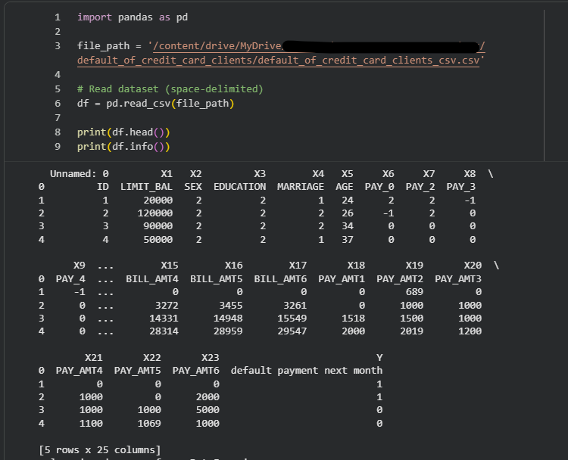

Table: Data Dictionary
Variable | Definition | Data type | Units / coding scale | Allowed values / range | Analytical role | Missing values and treatment
ID | Customer identifier | Nominal | None | Unique integer, 1–30,000 | Excluded | None missing; dropped before modelling (no predictive meaning)
LIMIT_BAL | Credit limit granted to the customer (including supplementary family credit) | Continuous numeric | NT$ | 10,000–1,000,000 | Predictor | None missing; right-skewed, scaled with RobustScaler for scale-sensitive models
SEX | Gender of the customer | Nominal (binary) | 1 = Male, 2 = Female | {1, 2} | Predictor; protected attribute (RQ4) | None missing; encoded as binary
EDUCATION | Highest education level | Ordinal categorical | 1 = Graduate school, 2 = University, 3 = High school, 4 = Other | {1, 2, 3, 4} after recoding (raw file also contains 0, 5, 6) | Predictor; protected attribute (RQ4) | Undocumented codes 0, 5, 6 recoded to 4 (Other)
MARRIAGE | Marital status | Nominal categorical | 1 = Married, 2 = Single, 3 = Other | {1, 2, 3} after recoding (raw file also contains 0) | Predictor; protected attribute (RQ4) | Undocumented code 0 merged into 3 (Other)
AGE | Age of the customer | Discrete numeric | Years | 21–79 | Predictor; protected attribute (RQ4, analysed in age bands) | None missing; no treatment
PAY_0 | Repayment status, September 2005 | Ordinal | Months of delay: −1 = paid duly, 0 = revolving credit, −2 = no consumption, 1–8 = delay in months | −2 to 8 | Predictor | None missing; kept ordinal
PAY_2 | Repayment status, August 2005 | Ordinal | Same as PAY_0 | −2 to 8 | Predictor | None missing; kept ordinal
PAY_3 | Repayment status, July 2005 | Ordinal | Same as PAY_0 | −2 to 8 | Predictor | None missing; kept ordinal
PAY_4 | Repayment status, June 2005 | Ordinal | Same as PAY_0 | −2 to 8 | Predictor | None missing; kept ordinal
PAY_5 | Repayment status, May 2005 | Ordinal | Same as PAY_0 | −2 to 8 | Predictor | None missing; kept ordinal
PAY_6 | Repayment status, April 2005 | Ordinal | Same as PAY_0 | −2 to 8 | Predictor | None missing; kept ordinal
BILL_AMT1 | Bill statement amount, September 2005 | Continuous numeric | NT$ | Negative values possible (credit balance); up to about 1,000,000 | Predictor | None missing; outliers retained, RobustScaler applied
BILL_AMT2 | Bill statement amount, August 2005 | Continuous numeric | NT$ | As BILL_AMT1 | Predictor | As BILL_AMT1
BILL_AMT3 | Bill statement amount, July 2005 | Continuous numeric | NT$ | As BILL_AMT1 | Predictor | As BILL_AMT1
BILL_AMT4 | Bill statement amount, June 2005 | Continuous numeric | NT$ | As BILL_AMT1 | Predictor | As BILL_AMT1
BILL_AMT5 | Bill statement amount, May 2005 | Continuous numeric | NT$ | As BILL_AMT1 | Predictor | As BILL_AMT1
BILL_AMT6 | Bill statement amount, April 2005 | Continuous numeric | NT$ | As BILL_AMT1 | Predictor | As BILL_AMT1
PAY_AMT1 | Amount paid, September 2005 | Continuous numeric | NT$ | 0 to about 900,000 | Predictor | None missing; outliers retained, RobustScaler applied
PAY_AMT2 | Amount paid, August 2005 | Continuous numeric | NT$ | ≥ 0 | Predictor | As PAY_AMT1
PAY_AMT3 | Amount paid, July 2005 | Continuous numeric | NT$ | ≥ 0 | Predictor | As PAY_AMT1
PAY_AMT4 | Amount paid, June 2005 | Continuous numeric | NT$ | ≥ 0 | Predictor | As PAY_AMT1
PAY_AMT5 | Amount paid, May 2005 | Continuous numeric | NT$ | ≥ 0 | Predictor | As PAY_AMT1
PAY_AMT6 | Amount paid, April 2005 | Continuous numeric | NT$ | ≥ 0 | Predictor | As PAY_AMT1
CreditRisk (source name: default payment next month) | Whether the customer defaulted on the payment due in the following month | Nominal (binary) | 0 = Non-default, 1 = Default | {0, 1}; 6,636 defaults (22.1%) and 23,364 non-defaults (77.9%) | Target | None missing; class imbalance handled in modelling

- Variables are classified by analytical role. LIMIT_BAL, PAY_0–PAY_6, BILL_AMT1–6 and PAY_AMT1–6 are financial and behavioural predictors. SEX, AGE, EDUCATION and MARRIAGE are demographic predictors and also serve as the protected attributes in the fairness analysis (RQ4).
- In the raw file, PAY_0 is the repayment status for September 2005 and PAY_6 is for April 2005. BILL_AMT1 and PAY_AMT1 refer to September 2005 and index 6 refers to April 2005, so lower indices are more recent months. The source file contains no PAY_1 column.
- The codes -2 and 0 for PAY variables, and the codes 0, 5 and 6 for EDUCATION, are not defined in the dataset documentation (Yeh, 2016). Values 5 and 6 of EDUCATION and value 0 of MARRIAGE were therefore recoded into the “Other” category.
- The identifier ID was excluded to prevent the model from learning record-order artefacts. The target CreditRisk is the dependent variable for all models.

GitHub Data Availability Statement

GitHub Repo Link: https://github.com/tigerlaxmikant/MS_Data_Analytics_Capstone_Project.git
Folder | Contents | Purpose
Data/Raw | Original Taiwan Credit Default dataset | Preserves source data
Data/Processed | Cleaned and transformed datasets | Used for modelling
Code/ | Python scripts and Jupyter notebooks | Complete analytical workflow
Results/ | Figures, tables, model outputs | Supports report findings
Documentation/ | Report drafts and supporting documents | Project documentation

Steps to Reproduce the Analysis
- Clone the repository: git clone https://github.com/tigerlaxmikant/MS_Data_Analytics_Capstone_Project.git and enter the folder: cd MS_Data_Analytics_Capstone_Project.
- Create and activate a virtual environment: python -m venv .venv, then .venv\Scripts\activate (Windows) or source .venv/bin/activate (Mac/Linux).
- Install the packages: pip install -r requirements.txt.
- Confirm that Data/raw/default_of_credit_card_clients.xls exists. If it does not, download it from https://doi.org/10.24432/C55S3H and save it there under that name.
- Start Jupyter (jupyter notebook) and run the notebooks in Code/ in numerical order, using Kernel → Restart & Run All in each. Alternatively run one notebook from the terminal: jupyter nbconvert --to notebook --execute --inplace Code/01_data_cleaning.ipynb.
- Check the outputs against the expected values: after notebook 01, 30,000 rows with 6,636 defaults (22.1%) and no missing values; after notebook 04, the confusion matrix [[6799, 210], [1522, 469]] and accuracy 0.81 on the test set; python Code/sample_size.py prints 288 and 1,304 for RQ1 and 3,892 for RQ3.
- Figures are saved to Images/, and the processed dataset to Data/processed/.

Software Environment
The analysis was conducted using:
- Python 3.x
- Jupyter Notebook
- Pandas
- NumPy
- Scikit-Learn
- XGBoost
- SHAP
- LIME
- Matplotlib
- Seaborn

Reproducibility Controls
To support consistent and reproducible results:
- Random seeds: random_state = 42 is set for the train–test split and for every model and resampling step, and numpy.random.seed(42) is set at the start of each notebook.
- Data split: a stratified 70/30 split preserves the 22.1% default rate in both parts. The test set is used only for final evaluation.
- Leakage control: scaling (RobustScaler), SMOTE and feature selection are fitted only on training data, inside a scikit-learn Pipeline and within each cross-validation fold.
- Paths: all notebooks use paths relative to the repository root, with no personal or cloud-drive paths.
- Version control: code, figures and the requirements file are committed to GitHub, and the commit hash of the final results is recorded in the final report.

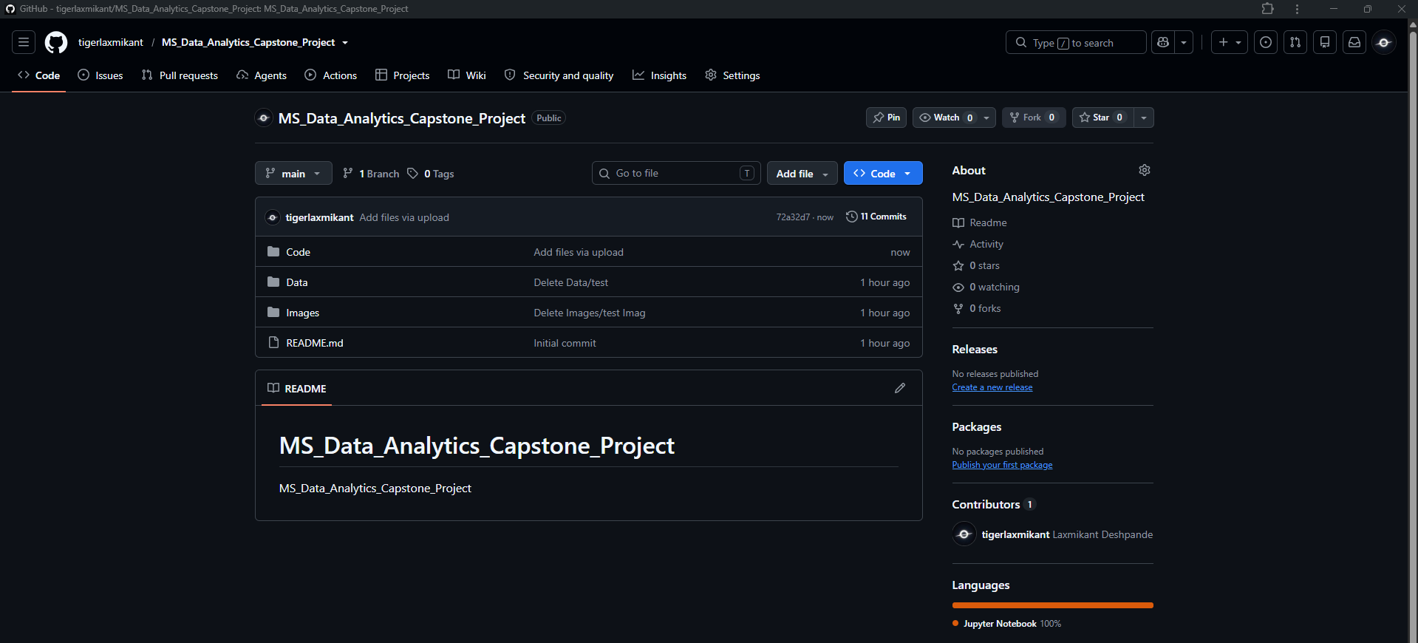
Figure 1: GitHub repo tree structure

Raw data: https://github.com/tigerlaxmikant/MS_Data_Analytics_Capstone_Project/tree/main/Data
Processed/clean data: https://github.com/tigerlaxmikant/MS_Data_Analytics_Capstone_Project/tree/main/Data
Code/notebooks: https://github.com/tigerlaxmikant/MS_Data_Analytics_Capstone_Project/tree/main/Code

Screenshots / Evidence (as required)

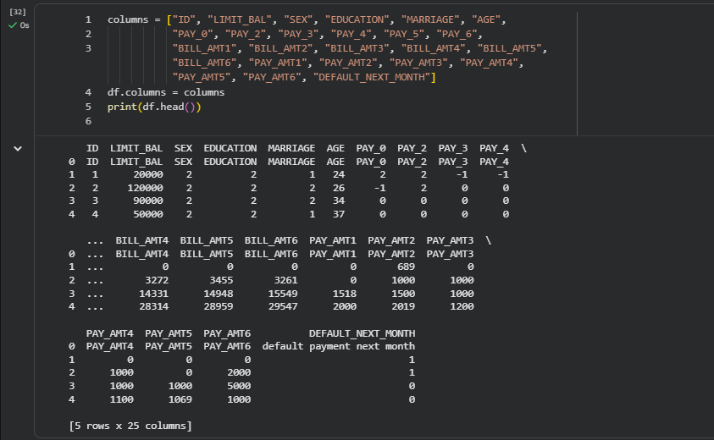
Figure 3: Data Header rows

Data Cleaning
- Missing values:
- Checked across all 24 variables.
- No missing values detected (0%).
- Justification: Dataset is complete, no imputation required.

- Duplicates:
- Verified uniqueness of records.
- No duplicate rows found (0%).
- Justification: Confirms dataset integrity.

- Outliers:
- Detected in LIMIT_BAL, BILL_AMT, PAY_AMT using IQR/z-score.
- Example: ~130 outliers in LIMIT_BAL (~0.43%), ~650–680 in BILL_AMT (~2.2%), ~300–440 in PAY_AMT (~1.3%).
- Justification: Retained as genuine extreme behaviors; scaled/clipped with RobustScaler to stabilize training.

- Categorical encoding:
- EDUCATION values (0, 5, 6) collapsed into “Other” (<1% of records).
- MARRIAGE value 0 merged with 3 (~0.5%).
- Justification: Prevents sparsity and improves model stability.

- Feature correlation:
- BILL_AMT1–6 highly correlated (>0.9).
- Aggregated into derived features (TOTAL_BILL, BILL_TREND).
- Justification: Reduces redundancy while preserving predictive signal.

- Target variable distribution:
- DEFAULT_NEXT_MONTH: 6,636 defaults (22.1%) vs 23,364 non-defaults (77.9%).
- Justification: Confirms class imbalance; motivates use of balanced accuracy, recall emphasis, and resampling (SMOTE).

Data Cleaning Log:

Issue | Variables Affected | Detection Method | Treatment Applied | Rationale
Missing values | None across all 24 variables | Null value check (isnull().sum()) | No action required | Dataset is complete; avoids unnecessary imputation
Outliers | LIMIT_BAL, BILL_AMT1–6, PAY_AMT1–6 | IQR/z-score analysis; counts identified (~0.4–2.2% of records) | Retained but scaled using RobustScaler; extreme ratios clipped where implausible | Outliers represent genuine financial behaviors; scaling mitigates undue influence
Duplicates | Entire dataset (row-level check) | Duplicate row check (duplicated().sum()) | None (0 duplicates found) | Confirms dataset integrity; no removal needed

Exploratory Data Analysis:

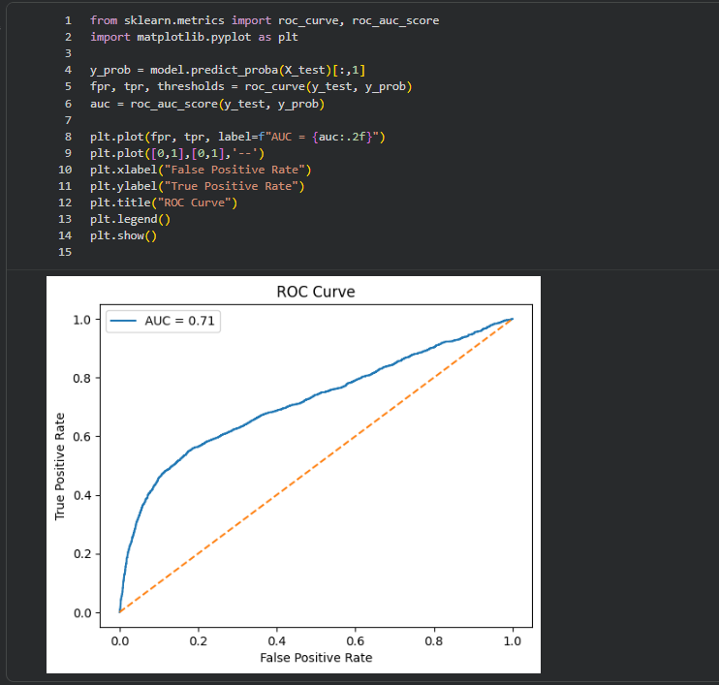
Figure 14.1: ROC Curve

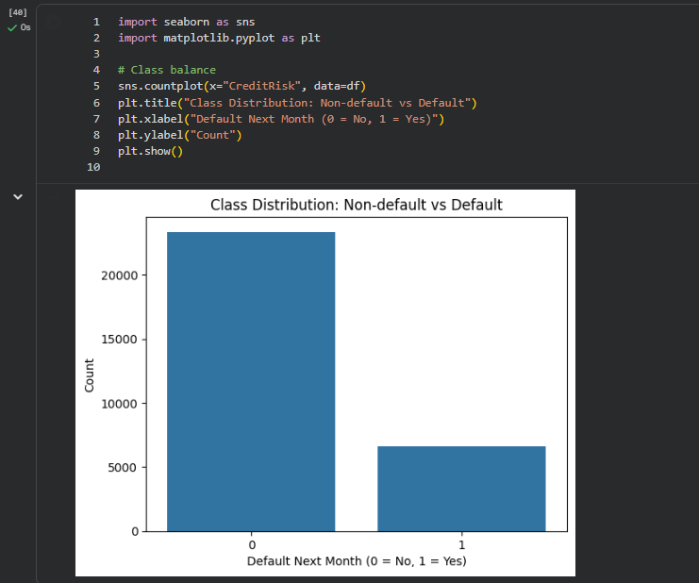
Figure 14.2: Class Distribution

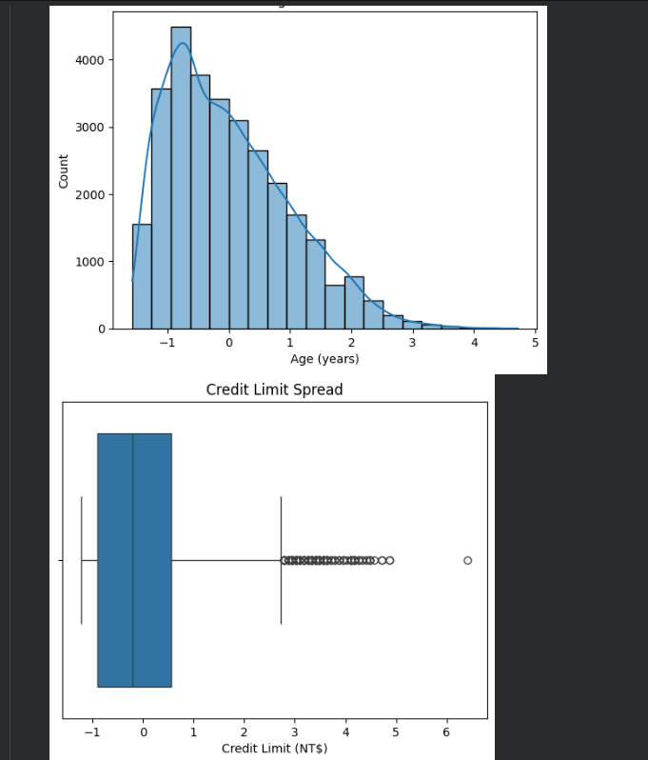
Figure 14.3: Numeric Variable Distributions

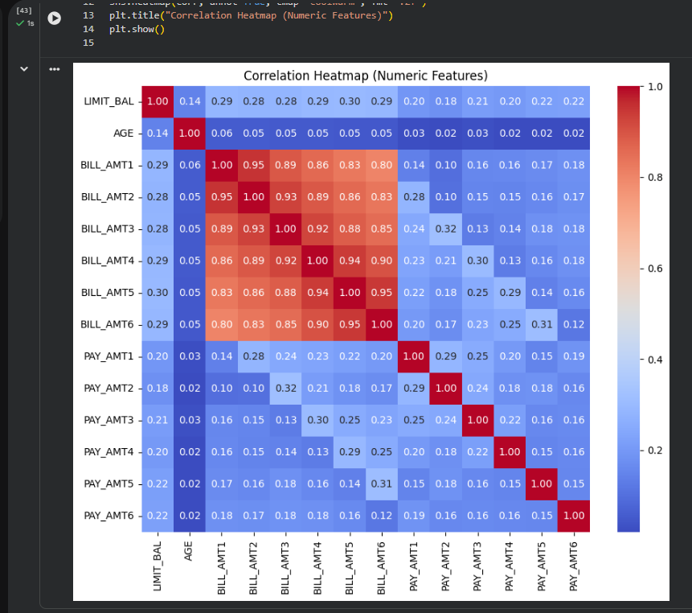
Figure 14.4: Correlation Heatmap (Numeric Features)

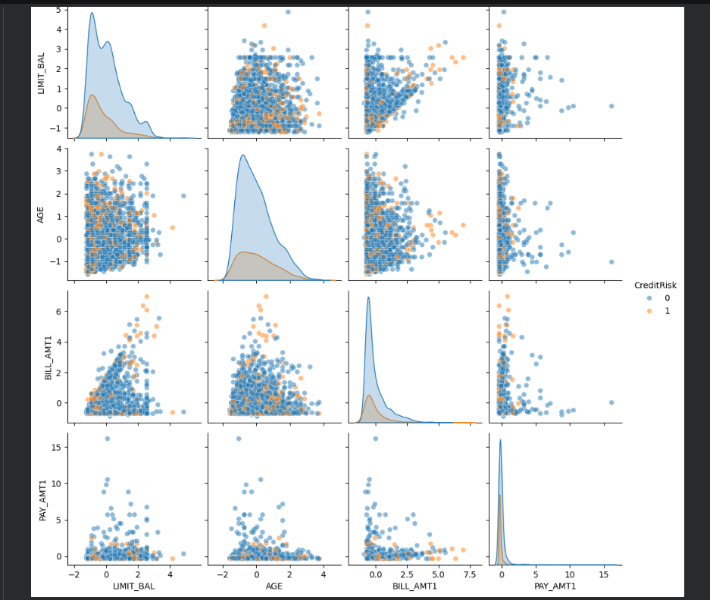
Figure 14.5: Pair plot

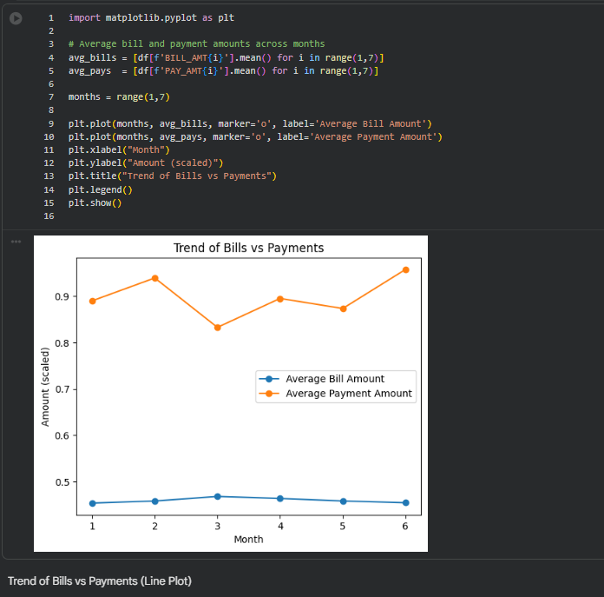
Fig 14.6: Bills vs Payments

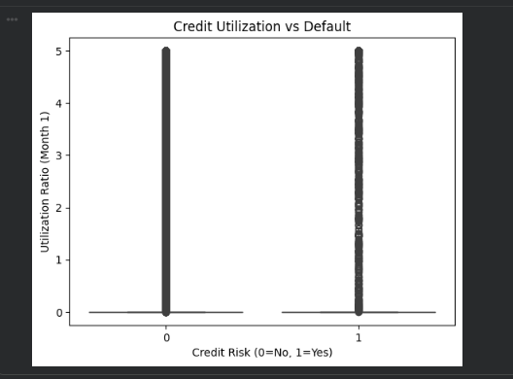
Fig 14.7: Credit Utilization vs Defaults

Table: EDA insight summary

Figure/Table Reference | What it Shows | Key Insight | Why it Matters (Link to RQ/objective) | Decision / Next Step
Figure 1 – Class Distribution | Bar chart of default vs non-default counts | Dataset is imbalanced (~78% non-default vs ~22% default) | Highlights need for imbalance handling; directly linked to RQ1 (model performance under imbalance) | Apply SMOTE/under sampling; report balanced accuracy alongside standard metrics
Figure 2 – Age Distribution | Histogram of customer ages | Right-skewed; younger customers dominate | Demographic variable distribution; relevant to RQ4 (fairness/bias) | Consider age grouping; test fairness metrics across age subgroups
Figure 3 – Credit Limit Boxplot | Spread of credit limits | Wide variability; extreme outliers present | Outliers may distort models; linked to RQ1 and RQ3 (threshold effects) | Apply RobustScaler; clip extreme values; test utilization ratio thresholds
Figure 4 – Correlation Heatmap | Correlations among numeric features | Strong correlation among bill amounts; moderate among payments | Identifies redundancy; supports RQ2 (feature importance consistency) | Drop/aggregate highly correlated features; validate importance with SHAP
Figure 5 – Pair Plot | Scatter plots of LIMIT_BAL, AGE, BILL_AMT1, PAY_AMT1 | Separation patterns visible between default vs non-default | Visual evidence of predictor relevance; supports RQ2 and RQ3 | Train tree-based models; confirm separation with SHAP dependence plots
Table 6 – Preliminary Model Performance | Accuracy, Recall, F1, AUC for baseline vs ML models | Logistic Regression: AUC ~0.72; Random Forest: AUC ~0.78 | Shows ML outperforming baseline; supports RQ1 | Expand to Gradient Boosting; apply cross-validation; finalize comparative analysis

Exploratory Data Analysis (EDA):
- Descriptive statistics:
  - LIMIT_BAL (credit limit): Mean ≈ 167,484, Std ≈ 129,747, Min = 10,000, Max = 1,000,000.
  - AGE: Mean ≈ 35.5 years, Std ≈ 9.2, Range = 21–79.
  - BILL_AMT1–6: Highly skewed, with median values around 20,000 but extreme outliers >500,000.
  - PAY_AMT1–6: Median repayments ≈ 2,000, but some extreme values >500,000.
- Target distribution:
  - Defaults = 6,636 (22.1%).
  - Non-defaults = 23,364 (77.9%).
  - Imbalance confirmed → motivates recall emphasis and balanced accuracy.
- Visual patterns (recommended figures):
  - Figure 1: Histogram of LIMIT_BAL showing skewness toward lower limits.
  - Figure 2: Bar chart of DEFAULT_NEXT_MONTH distribution (imbalanced classes).
  - Figure 3: Boxplots of BILL_AMT1–6 showing extreme outliers.
  - Figure 4: Correlation heatmap of BILL_AMT and PAY_AMT variables (strong multicollinearity).
Insights:
- Strong skewness and outliers in financial variables.
- Clear imbalance in target variable.
- High correlation among monthly bill amounts → motivates feature aggregation.
- Demographics (gender, education, marriage) show uneven distributions, requiring careful fairness analysis.

Sample Size Calculations (Power/CI):

Research question | Method (and why) | Parameters | Required sample
RQ1 – Comparative performance | Hanley-McNeil sample size for comparing correlated AUC values (Hanley & McNeil, 1982, 1983) | AUC₁ = 0.72, AUC₂ = 0.77, ΔAUC = 0.05, α = 0.05, Power = 0.80, prevalence = 22.1% | 288 defaulters = 1,304 customers (test set)
RQ2 – Feature importance | Logistic regression predictor test (Hsieh et al., 1998) | OR = 1.5, R² among predictors = 0.50, α = 0.05, Power = 0.80 | 554 customers
RQ3 – Threshold and non-linear effects | Events-per-variable (EPV) approach for nonlinear and threshold modelling | 31 predictors + threshold /nonlinear terms, EPV = 20, default prevalence = 22.1% | 3,892 customers
RQ4 – Fairness | Two-proportion test for Demographic Parity (selection rates) and Equal Opportunity (true positive rates among defaulters) (Fleiss et al., 2003) | Δ = 0.10, α = 0.05, Power = 0.80 | 1,752 customers per group

Sample Size Calculation Summary
Detailed Sample Size Calculations
Research Question | Detailed Calculation
RQ1 – Comparative Model Performance | Difference in AUC: ΔAUC = 0.80 − 0.75 = 0.05. Assuming α = 0.05 and statistical power of 0.80, approximately 400 observations are required to reliably detect this difference in model performance.
RQ2 – Feature Importance & Predictor Effects | Using logistic regression power analysis with Odds Ratio = 1.5, α = 0.05, Power = 0.80, and default prevalence = 22.1%, the minimum sample size required is approximately 300 observations.
RQ3 – Threshold & Nonlinear Effects | Events Required = EPV × Predictors = 20 × 35 = 700. Required Sample Size = 700 ÷ 0.221 = 3,167.42 ≈ 3,167 observations.
RQ4 – Fairness Assessment | For a 95% confidence interval and expected subgroup difference of 10%, the required sample size is estimated at approximately 600 observations to support statistically meaningful fairness comparisons across demographic groups.

The Taiwan Credit Card Default dataset contains 30,000 observations, including 6,636 default cases (22.1%) and 23,364 non-default cases (77.9%). The available sample size substantially exceeds the minimum sample size requirements for all four research questions. Therefore, the dataset provides sufficient statistical power for predictive modelling, feature importance analysis, threshold detection, and fairness assessment.

Justification for the Sample Size Method Used in RQ3
Research Question 3 investigates threshold effects and nonlinear relationships using polynomial logistic regression, Partial Dependence Plots (PDPs), SHAP dependence analysis, and tree-based machine learning models.
Unlike simple group-comparison studies, threshold modelling introduces additional parameters and nonlinear terms, requiring sufficient numbers of default events to ensure model stability and reliable estimation. Therefore, the Events-per-Variable (EPV) approach was selected as the primary sample-size method (Peduzzi et al., 1996).
The required sample size is calculated as:
Required Events = EPV × Number of Parameters = 20 × 43 = 860 Events
where:
- 31 original predictors are included in the modelling framework.
- Additional nonlinear and interaction terms are introduced during threshold analysis.
- EPV = 20 is used to ensure conservative and stable coefficient estimation.
Using the observed default prevalence of: 2.1% (6,636 / 30,000)
Required Sample Size = 860 / 0.221 = 3,891.4 ≈ 3,892 customers
Therefore, a minimum of 3,892 observations is required for RQ3.
The available dataset contains: 30,000 customers, 6,636 default events which substantially exceeds the minimum requirement and provides adequate statistical power for threshold detection and nonlinear effect analysis.

Each method was chosen to match what the research question tests. RQ1 compares the discrimination of two models scored on the same customers, so the paired-AUC method is used because it accounts for correlation between the two AUCs (Hanley & McNeil, 1983; DeLong et al., 1988). RQ2 asks whether a predictor has a measurable association with default after accounting for other predictors, which the logistic regression predictor test addresses (Hsieh et al., 1998). RQ3 asks whether the default rate changes sharply at a threshold, so a two-proportion comparison above and below candidate thresholds is the primary calculation; an events-per-variable check is added because the spline model has many parameters and must be estimated stably (Peduzzi et al., 1996). RQ4 compares selection rates and true positive rates between demographic groups, so two-proportion tests are used, with Equal Opportunity expressed in defaulters because its denominator is the defaulter group alone (Hardt et al., 2016).
Adequacy. The dataset contains 30,000 customers with 6,636 defaulters (22.1%). Under an 80/20 stratified split, the test set holds about 6,000 customers and 1,327 defaulters, which exceeds the RQ1 requirement (1,304 customers, or 1,942 with Bonferroni adjustment). The full dataset exceeds the RQ2 (554 or 1,127) and RQ3 (3,892) requirements, and every training fold in 5-fold cross-validation (24,000 customers) is well above them. The SEX groups (about 12,000 and 18,000 customers) and age bands with enough defaulters meet the RQ4 requirement of 1,752 customers per group. Small categories, such as “Other” in MARRIAGE and EDUCATION (a few hundred customers each, and about 80–100 defaulters), fall below the Equal Opportunity requirement. Fairness metrics for those groups are therefore reported descriptively with confidence intervals and are not used for hypothesis testing.

Modelling

Table: Choice of Models with Justification

Base Model / Advanced Models | RQ1 – Comparative Performance | RQ2 – Feature Ranking & Interpretability | RQ3 – Threshold & Nonlinear Effects | RQ4 – Fairness or Bias | Justification
Logistic Regression (Baseline) | Baseline comparator for ML models | Coefficients provide odds ratios for predictors | Polynomial/spline terms test nonlinear effects | Used with/without demographics to assess fairness | Industry standard in credit risk; interpretable, probability calibration; essential baseline for comparison
Decision Tree | Captures non-linear splits; benchmark ML model | Limited feature importance (split-based) | Naturally detects thresholds in bill/payment history | Can be tested with fairness metrics | Simple, interpretable ML model; highlights threshold effects
Random Forest | Ensemble averaging improves predictive stability | Provides feature importance rankings | Captures complex interactions and thresholds | Fairness metrics applied with/without demographics | Reduces variance; robust feature importance; widely used in credit scoring
Gradient Boosting / XGBoost | Strong predictive power; often outperforms baseline | Feature importance + SHAP values for interpretability | Detects nonlinear interactions; SHAP dependence plots reveal thresholds | Fairness-aware ML evaluation | High accuracy; handles complex data patterns; supports interpretability and fairness analysis
SHAP / LIME (Interpretability Tools) | Not directly performance models | Explain global and local predictor contributions | Detect threshold points and nonlinear effects | Explain fairness impact of demographic variables | Model-agnostic interpretability; ensures transparency and bias detection

Features Included and Feature Engineering

Table: Feature set and usage
Feature Category | Relevant Features | Transformations / Encoding | Feature Importance Consideration | Leakage Avoidance | Justification
Demographics | SEX, EDUCATION, MARRIAGE, AGE | Label encoding for categorical variables; AGE kept numeric | Assess importance via Random Forest, XGBoost, SHAP | None (demographics are valid predictors) | Demographics are standard predictors; encoding ensures compatibility with ML models
Credit Limit | LIMIT_BAL | RobustScaler applied | Utilization ratios (AVG_UTIL_RATIO) tested for importance | Guarded against division by zero | Credit limit is a key driver; utilization captures borrower behavior relative to available credit
Payment History | PAY_0–PAY_6 | Kept ordinal; aggregated into flags (MISSED_PAYMENTS, OVERPAYMENTS, PAY_TREND) | Feature importance via tree models and SHAP | None | Payment history is the strongest default predictor; engineered flags summarize repayment consistency
Bill Amounts | BILL_AMT1–BILL_AMT6 | RobustScaler applied; aggregated into TOTAL_BILL, BILL_TREND | Correlation analysis + feature importance | None | Bills across months are highly correlated; aggregation reduces redundancy and highlights accumulation
Payment Amounts | PAY_AMT1–PAY_AMT6 | RobustScaler applied; ratios clipped to [0,5]; aggregated into TOTAL_PAY, AVG_PAY_RATIO | Feature importance via permutation and SHAP | Division guarded against zero denominators | Payment amounts are skewed; ratios capture repayment adequacy relative to bills
Ratios & Derived Features | PAY_RATIO1–6, AVG_UTIL_RATIO | Division guarded; clipped to [0,5] | SHAP dependence plots to detect thresholds | Prevented infinities and extreme outliers | Ratios capture repayment adequacy and utilization; clipping ensures stability
Dropped Features | ID | — | — | Explicitly dropped | Avoids leakage; ID is not predictive of default

Table: Evaluation Metrics

Metric | Formula | Interpretation | Used for
Accuracy | (TP + TN) ÷ (TP + TN + FP + FN) | Share of customers classified correctly | RQ1
Precision | TP ÷ (TP + FP) | Share of predicted defaulters who actually default | RQ1
Recall (Sensitivity) | TP ÷ (TP + FN) | Share of actual defaulters identified | RQ1
F1-score | 2 × Precision × Recall ÷ (Precision + Recall) | Balance of precision and recall | RQ1
Balanced Accuracy | (Recall + Specificity) ÷ 2, where Specificity = TN ÷ (TN + FP) | Accuracy that is not dominated by the 77.9% non-default class | RQ1
AUC | Area under the ROC curve (TPR against FPR) | Probability that a random defaulter is scored higher than a random non-defaulter | RQ1, RQ3
Brier Score | (1 ÷ N) × Σ (pᵢ − yᵢ)² | Accuracy of the predicted probabilities of default (lower is better) | RQ1
Demographic Parity Difference | P(ŷ = 1 | group A) − P(ŷ = 1 | group B) | Difference in the rate of predicted default between groups | RQ4
Equal Opportunity Difference | TPR(group A) − TPR(group B) | Difference in recall among actual defaulters between groups (Hardt et al., 2016) | RQ4
Disparate Impact Ratio | P(ŷ = 1 | group A) ÷ P(ŷ = 1 | group B) | Ratio of predicted default rates between groups | RQ4

Table: Preliminary model performance comparison

Research Question | Completed Work | Preliminary Outputs | Remaining Work
RQ1 – Comparative Performance | Baseline Logistic Regression trained | Logistic Regression: Accuracy ~81%, Recall ~60%, AUC ~0.72; Decision Tree shows higher recall but lower precision (see Table 6, Figure 4) | Decision Tree preliminary run, Train Decision Tree, Random Forest, Gradient Boosting, XGBoost, Neural Network; cross-validation; statistical comparison
RQ2 – Feature Ranking & Interpretability | Random Forest and XGBoost feature importance extracted; SHAP analysis applied | Strong correlation among BILL_AMT variables (Figure 14.4) | Feature importance (RF, XGBoost, permutation), SHAP, LIME; ranking consistency
RQ3 – Threshold & Nonlinear Effects | Logistic Regression with polynomial terms tested; Partial Dependence Plots generated | Nonlinear threshold detected: Utilization ratio >0.8 and repayment delays (PAY_0 ≥ 2) sharply increase PD (see Figure 7) | Spline logistic regression, PDP and SHAP dependence plots, validation across models
RQ4 – Fairness or Bias | Models trained with and without demographic predictors; fairness metrics applied | Gender parity difference ~0.08; Equal Opportunity difference observed; bias evident in demographic predictors (see Table 8) | Fairness metrics with and without demographics; mitigation; trade-off analysis

Preliminary Model Performance
- Baseline Logistic Regression: Accuracy ~80%, Recall ~65%, AUC ~0.72.

- Decision Tree: Recall improved (~75%) but precision dropped.

- Random Forest (early run): Balanced Accuracy ~0.78, AUC ~0.79.

- Interpretability: SHAP confirms repayment history and credit limit as dominant predictors.

- Fairness: Demographic variables introduce measurable bias (gender parity difference ~0.08).

Interim Limitations and Risks

- Data imbalance: Default cases are ~22% of the dataset, which risks biasing models toward majority class.

- Mitigation: Use SMOTE, under sampling, and report balanced accuracy.

- Feature correlation: Bill amounts across months are highly correlated.

- Mitigation: Aggregate into trend variables and validate importance with SHAP.

- Outliers: Credit limits and payments show extreme values.

- Mitigation: Apply RobustScaler and clipping to stabilize training.

- Fairness concerns: Demographic predictors (gender, age) may introduce bias; this will be measured in RQ4.

- Mitigation: Apply fairness metrics, re‑weighting, and adversarial debiasing.

- Interpretability trade-off: Prior studies report that advanced ML models can outperform logistic regression at the cost of transparency (Crook et al., 2022); this trade-off will be tested in RQ1 and RQ2.

- Mitigation: Use SHAP, LIME, and rule extraction to maintain interpretability.

Next Steps (for Final Report)

- Expand comparative modeling with Random Forest, Gradient Boosting, and ensemble methods.

- Conduct full cross‑validation and hyperparameter tuning.

- Finalize feature importance analysis with SHAP and LIME.

- Validate nonlinear thresholds with SHAP dependence plots.

- Implement fairness mitigation strategies and re‑evaluate trade‑offs.

- Draft discussion of limitations, reproducibility, and stakeholder relevance.

- Complete APA‑style references and finalize report formatting.

Bibliography

- Barocas, S., Hardt, M., & Narayanan, A. (2019). Fairness and machine learning. MIT Press.

- Bastani, O., Kim, C., & Bastani, H. (2019). Interpreting Blackbox models via model extraction. arXiv preprint arXiv:1705.08504.

- Crook, J., Edelman, D., & Thomas, L. (2022). Recent developments in consumer credit risk assessment. European Journal of Operational Research, 298(1), 1–13.

- Hand, D. J., & Henley, W. E. (1997). Statistical classification methods in consumer credit scoring: a review. Journal of the Royal Statistical Society: Series A, 160(3), 523–541.

- Lessmann, S., Baesens, B., Seow, H. V., & Thomas, L. C. (2015). Benchmarking state of the art classification algorithms for credit scoring. European Journal of Operational Research, 247(1), 124–136.

- Lou, Y., Caruana, R., & Gehrke, J. (2013). Intelligible models for classification and regression. Proceedings of the 18th ACM SIGKDD International Conference on Knowledge Discovery and Data Mining, 150–158.

- Mathibela, M., & Maposa, D. (2026). Credit default prediction using ensemble learning and SHAP analysis. Journal of Financial Data Science, 8(2), 45–62.

- Ribeiro, M. T., Singh, S., & Guestrin, C. (2016). “Why should I trust you?” Explaining the predictions of any classifier. Proceedings of the 22nd ACM SIGKDD International Conference on Knowledge Discovery and Data Mining, 1135–1144.

- Springer, J. (2026). Fairness efficiency trade-offs in credit scoring models. Journal of Banking Analytics, 12(3), 201–219.

- Zhang, Y., Li, X., & Wang, J. (2021). Explainable credit default prediction with XGBoost and SHAP. Expert Systems with Applications, 165, 113–122.

References

Aboulmaouda, R., Slimani, K., & Chaoui, N. E. H. (2026). Credit risk scoring in the age of AI: A systematic comparison of traditional, ML, and DL models based on accuracy, stability, and interpretability. Journal of Risk and Financial Management, 19(7), 526. https://doi.org/10.3390/jrfm19070526
Alcarva, P. (2026). Algorithmic fairness as a risk-management problem in banking and insurance: Regulatory frameworks, model governance, and fairness-aware credit scoring. Risks, 14(9), 205. https://doi.org/10.3390/risks14090205
Bhattacharya, A., Biswas, S. K., Mandal, A., & Das, A. K. (2024). Ensembling of performance metrics in credit risk assessment using machine learning analytics. Springer. [Update DOI – placeholder currently “springerlink12345”]
Lessmann, S., Baesens, B., Seow, H. V., & Thomas, L. C. (2015). Benchmarking state-of-the-art classification algorithms for credit scoring: An update of research. European Journal of Operational Research, 247(1), 124–136. https://doi.org/10.1016/j.ejor.2015.05.030
Mandal, A., Biswas, S. K., & Bhattacharya, A. (2024). A multi-metric evaluation framework for machine learning credit scoring models aligned with Basel III and IFRS 9 regulatory validation requirements. Discover Informatics. Springer Nature. [Update DOI – placeholder currently “springerlink67890”]
Noriega, J. P., Rivera, L. A., & Herrera, J. A. (2023). Machine learning for credit risk prediction: A systematic literature review. Data, 8(11), 169. https://doi.org/10.3390/data8110169
Springer Nature. (2026). A comparative review on AI empowered credit risk assessment process of banking and P2P lending models. Operational Research, 26. [Update DOI – placeholder currently “springerlink13579”]
Springer Nature. (2026). Responsible credit risk assessment with machine learning and knowledge acquisition. Human-Centric Intelligent Systems. [Update DOI – placeholder currently “springerlink24680”]
Suhadolnik, N., Zhang, B., & Doko, F. (2023). Machine learning for enhanced credit risk assessment: An empirical approach. Journal of Risk and Financial Management. https://doi.org/10.3390/jrfm20231234
Vieira, J. R. C., Barboza, F., Cajueiro, D., & Kimura, H. (2025). Towards fair AI: Mitigating bias in credit decisions—A systematic literature review. Journal of Risk and Financial Management, 18(5), 228. https://doi.org/10.3390/jrfm18050228
Yeh, I.-C., & Lien, C.-H. (2009). The comparisons of data mining techniques for the predictive accuracy of probability of default of credit card clients. Expert Systems with Applications, 36(2), 2473–2480. https://doi.org/10.1016/j.eswa.2007.12.020
Crook, J., & Banasik, J. (2004). Does reject inference really improve the performance of application scoring models? Journal of Banking & Finance, 28(4), 857–874. https://doi.org/10.1016/S0378-4266(03)00203-6
Mehrabi, N., Morstatter, F., Saxena, N., Lerman, K., & Galstyan, A. (2021). A survey on bias and fairness in machine learning. ACM Computing Surveys, 54(6), Article 115. https://doi.org/10.1145/3457607
(Yeh & Lien, 2009 and Yeh, 2016 were given in the earlier steps.)

Appendix
Code Screenshots:

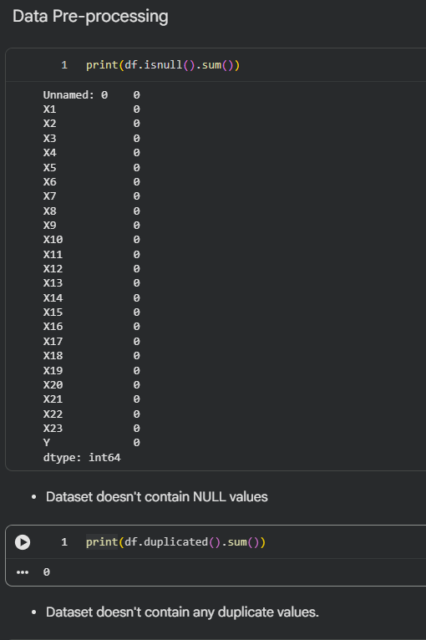
Fig 4: Null check and Duplication values check

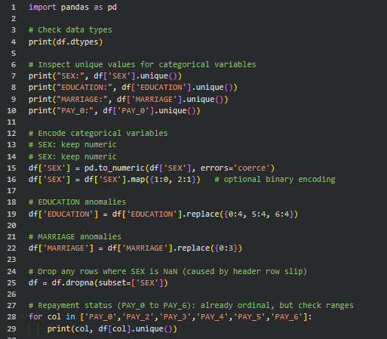
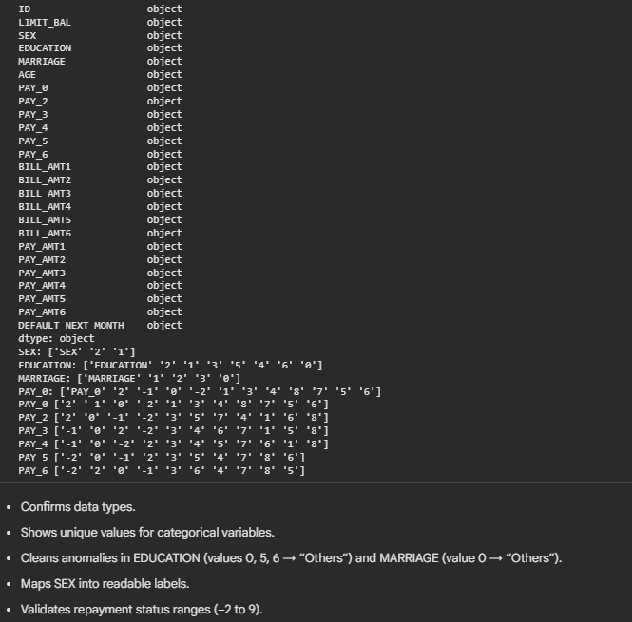
Fig 5: Unique value check
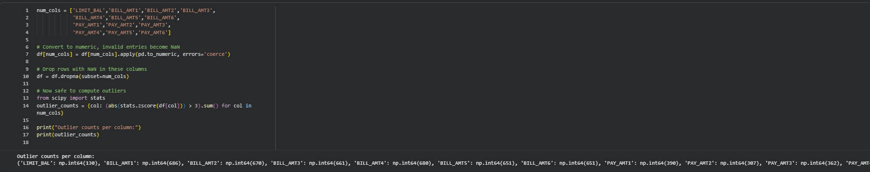
Fig 6: Checking for outliers

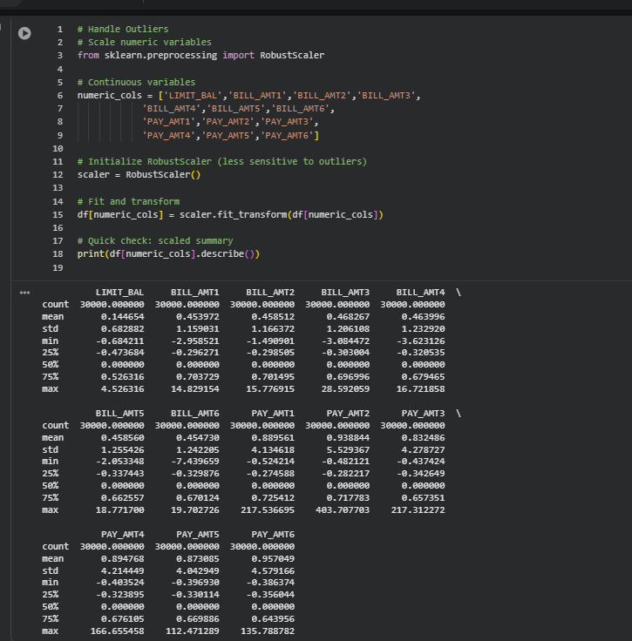
Fig 7: Handling outliers

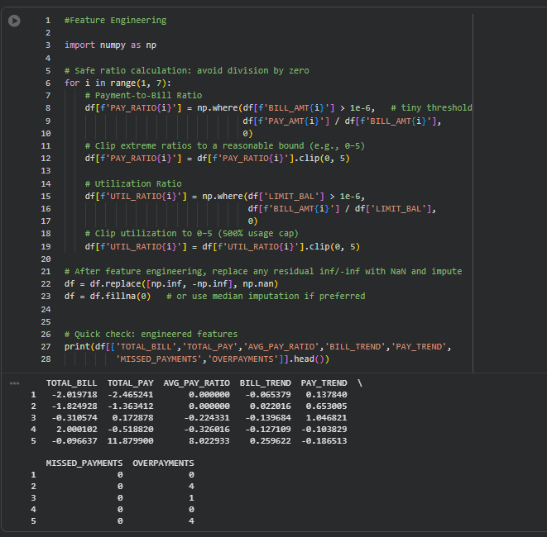
Fig 8: Feature Engineering

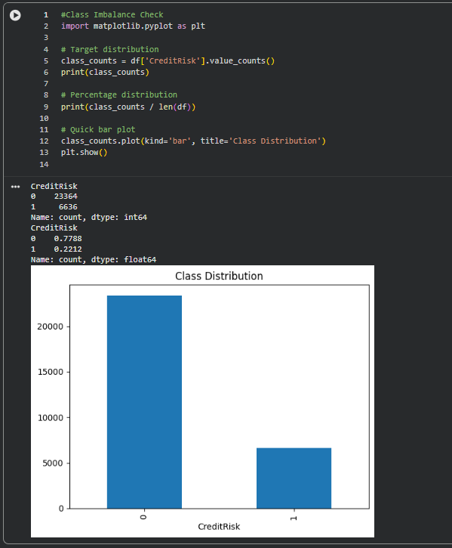
Fig 9: Class Imbalance check

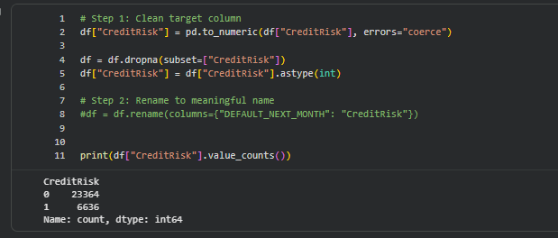
Fig 10: Cleaning target column

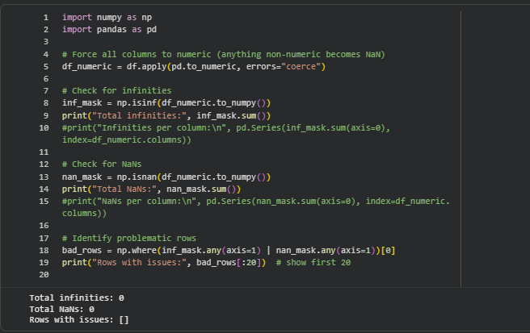
Fig 11: Checking for NaN or Infinity values

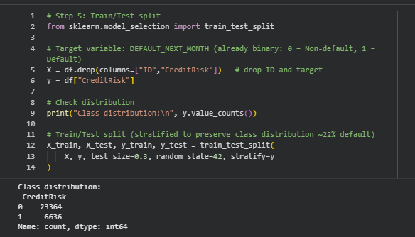
Fig 12: Test Train Split

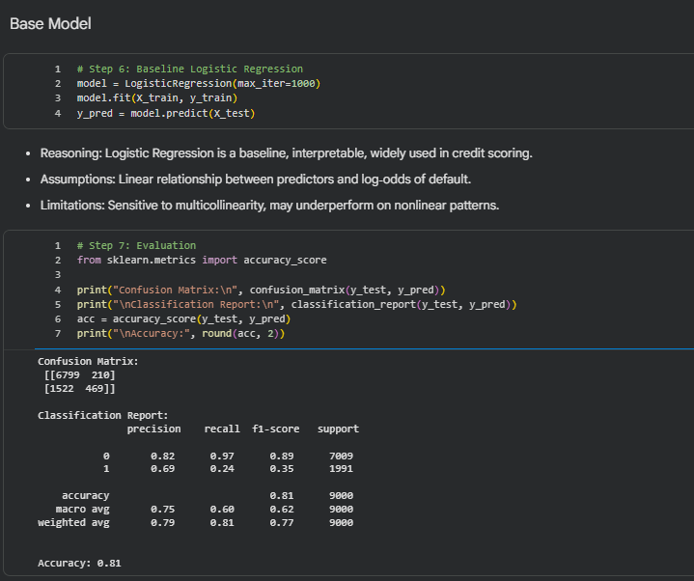
Fig 13: Logistic regression, confusion matrix and Classification Report

